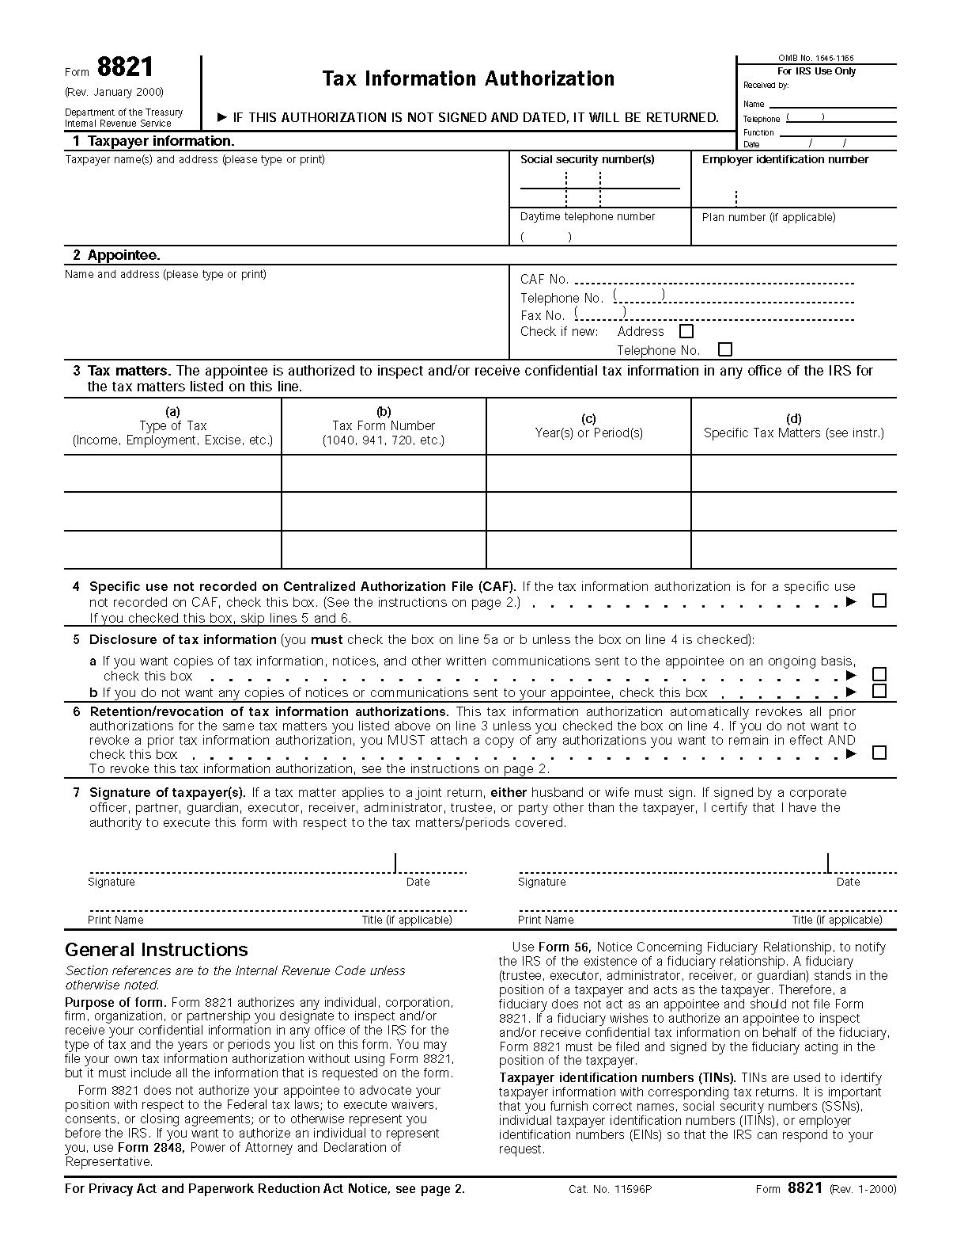
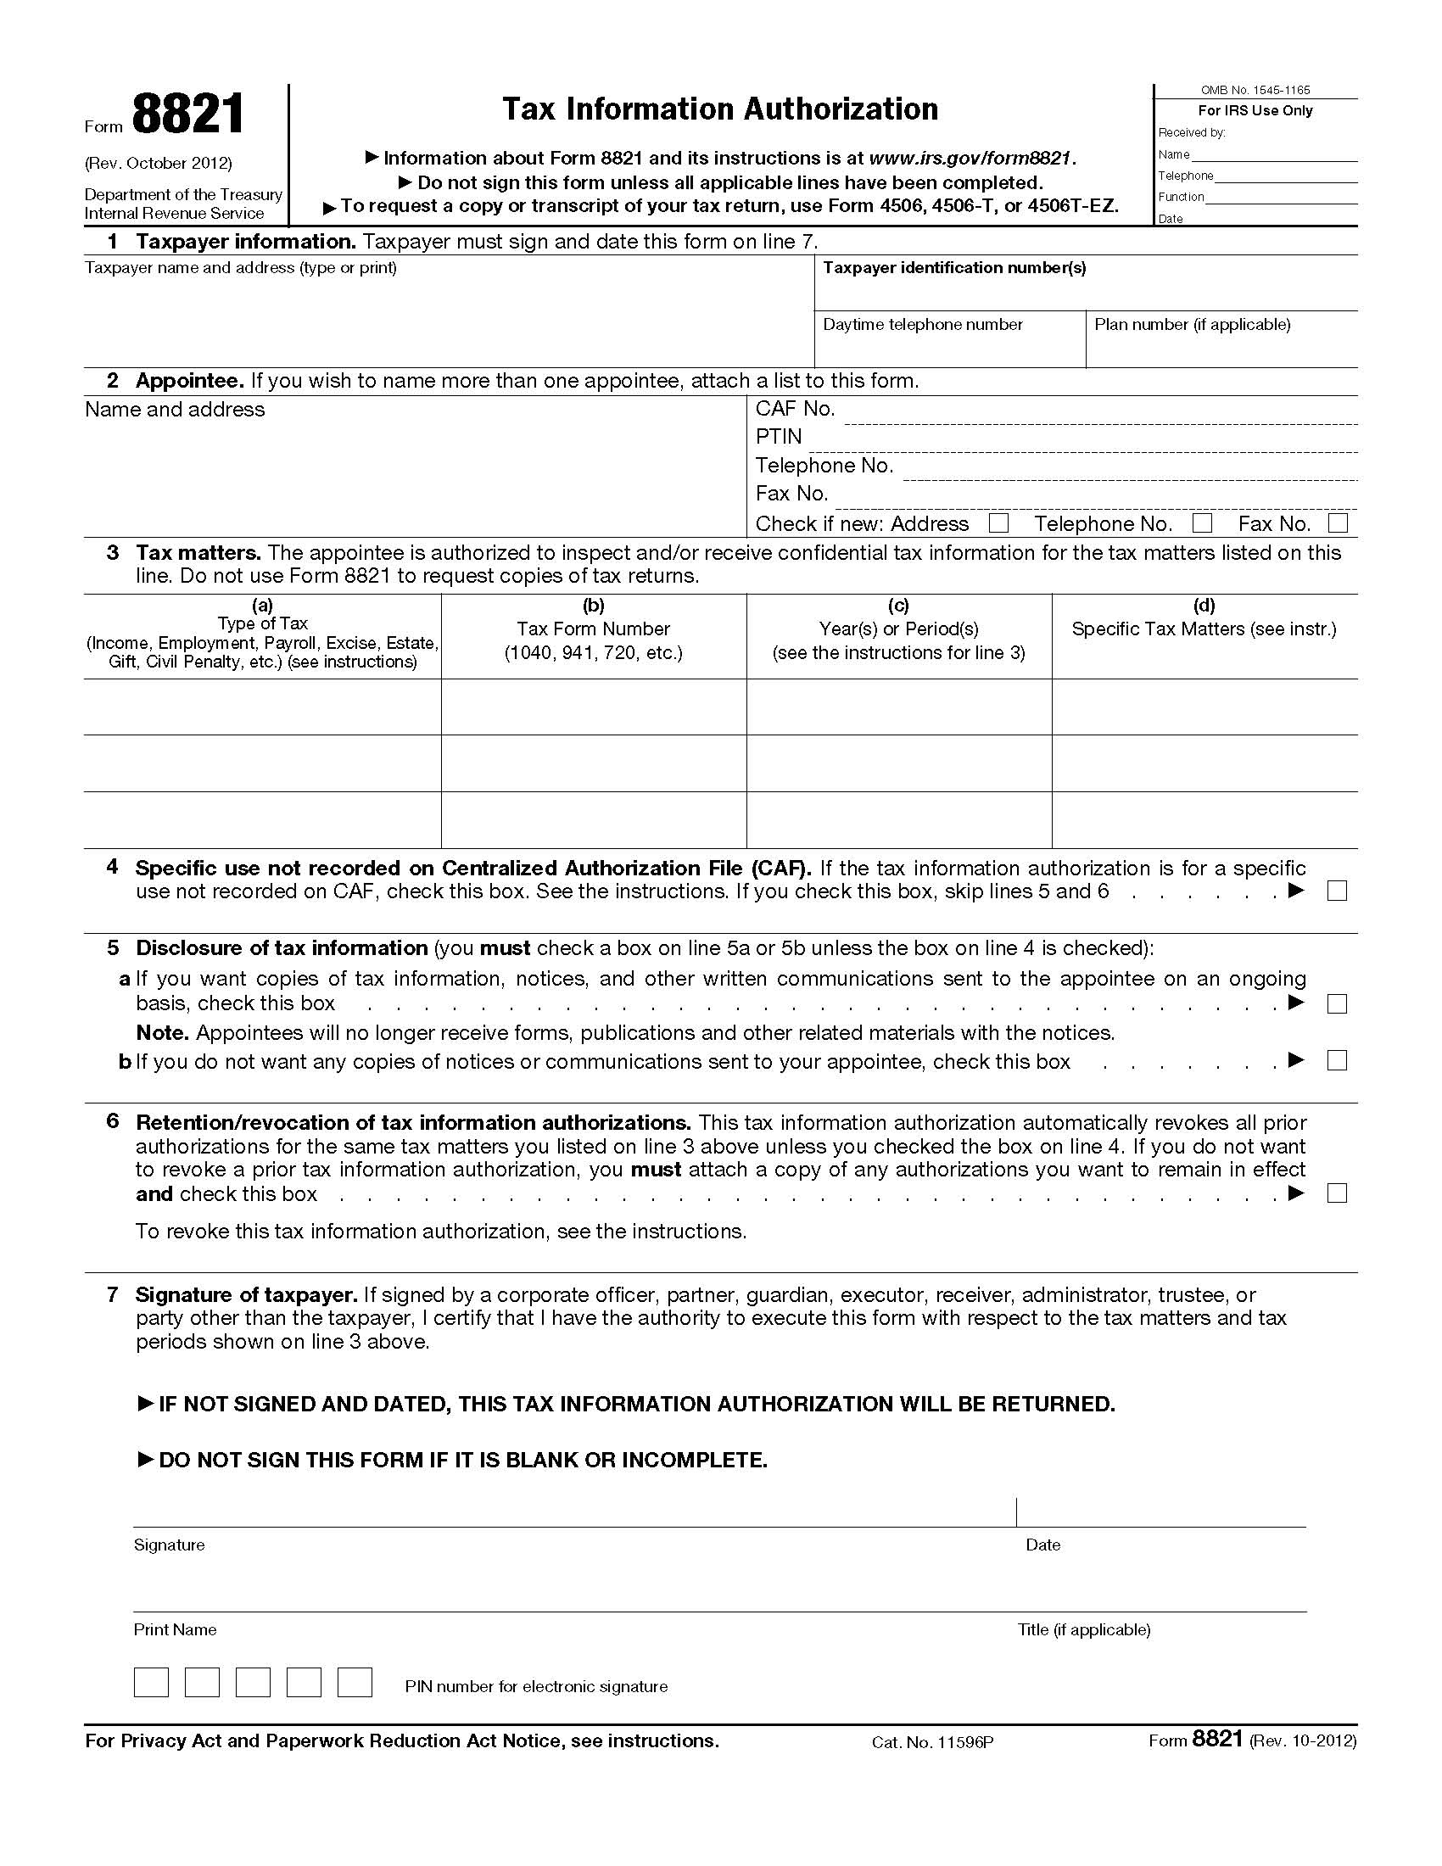
Juliana Opatowski
18 Cottage Drive
Farmingdale, NY 11738
XXX-XX-4348
Axiom Requisition Copy Service
2869 Jolly Rd
Okemos, Michigan 48864
Income/Employment, Payroll
1040
Years
Juliana Opatowski

X
Order No. 01-25592 - 012

